MODULE 1
- https://www.hackerearth.com/practice/basic-programming/input-output/basics-of-input-output/practice-problems/algorithm/io-exercise/?update=google&purpose=login&source=login

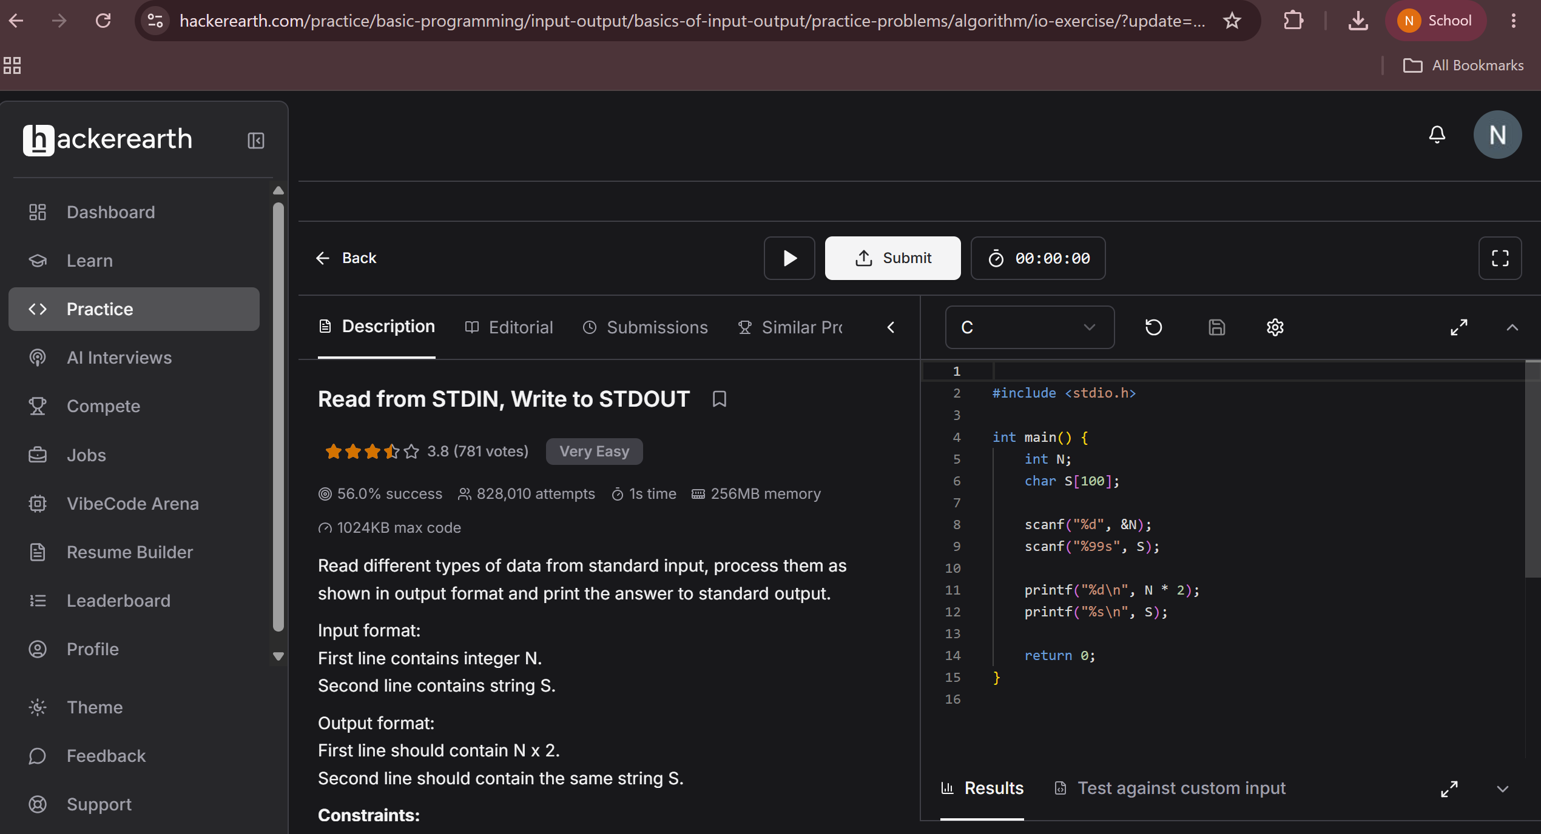
- https://www.hackerrank.com/challenges/solve-me-first/problem

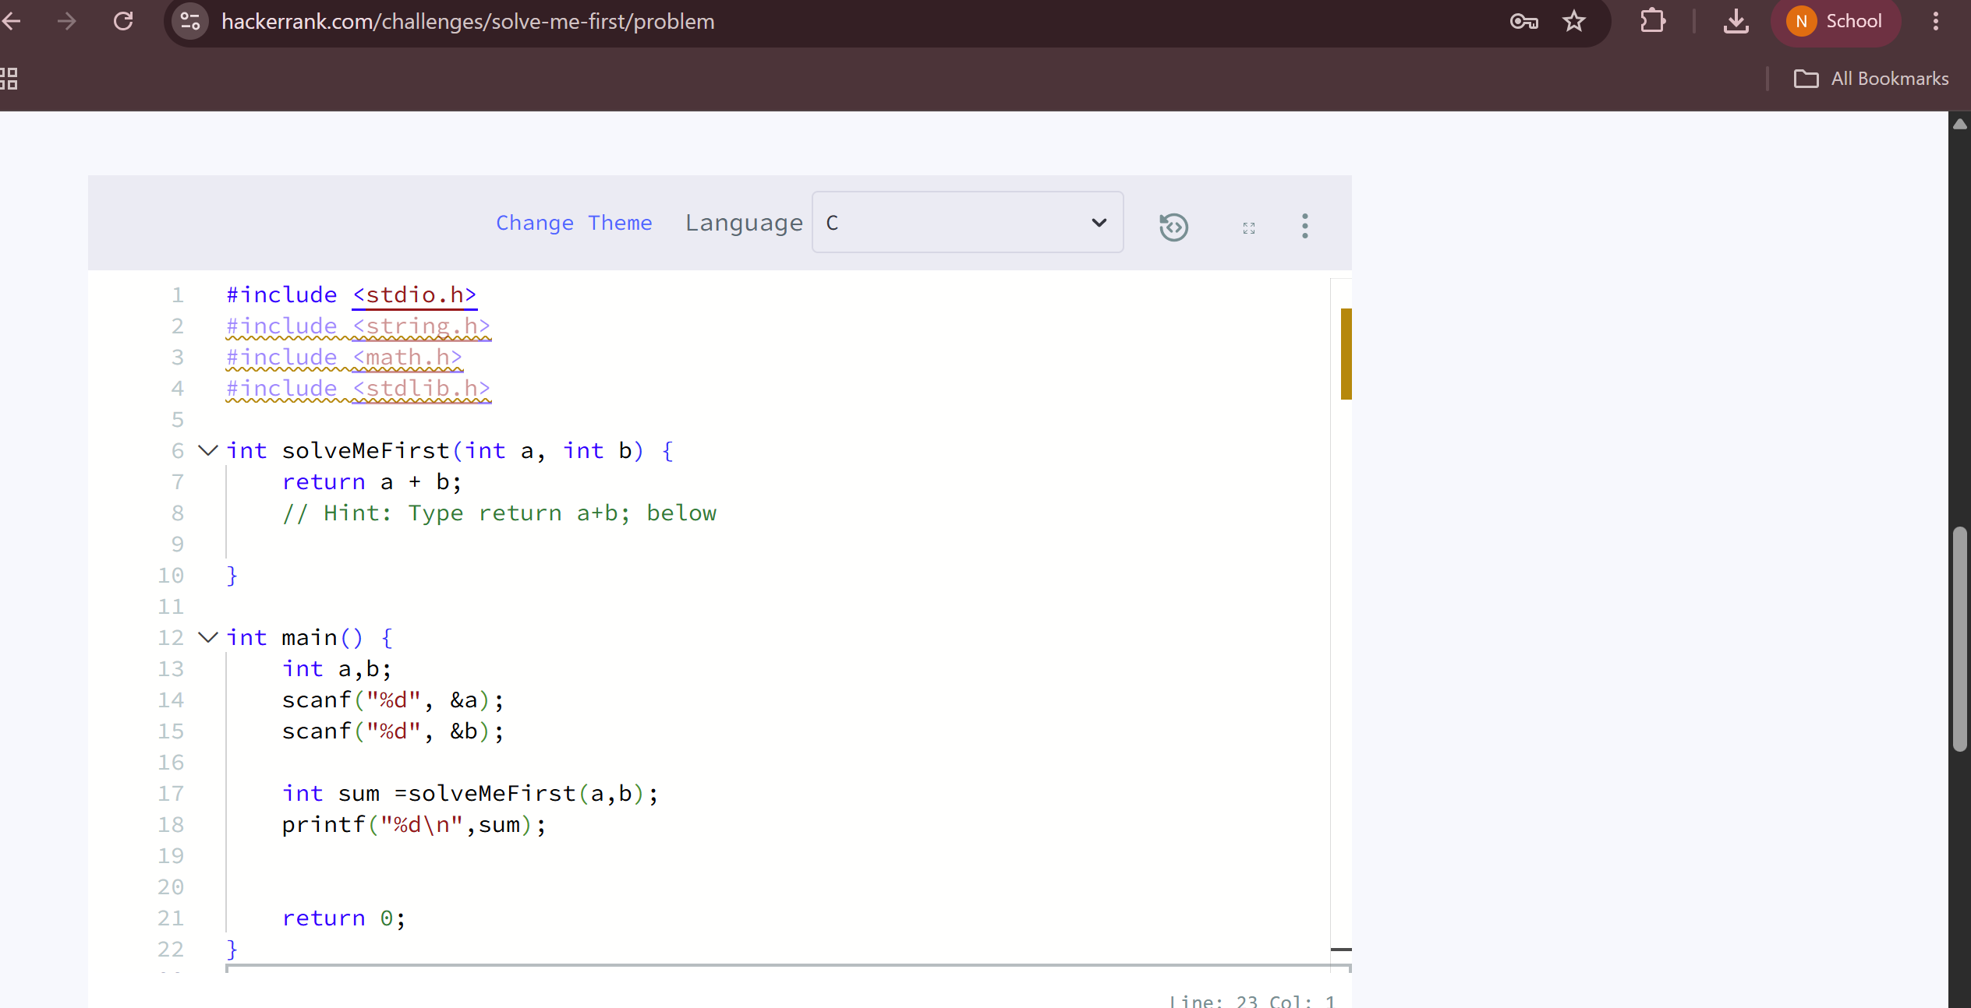
- https://leetcode.com/problems/add-two-integers/

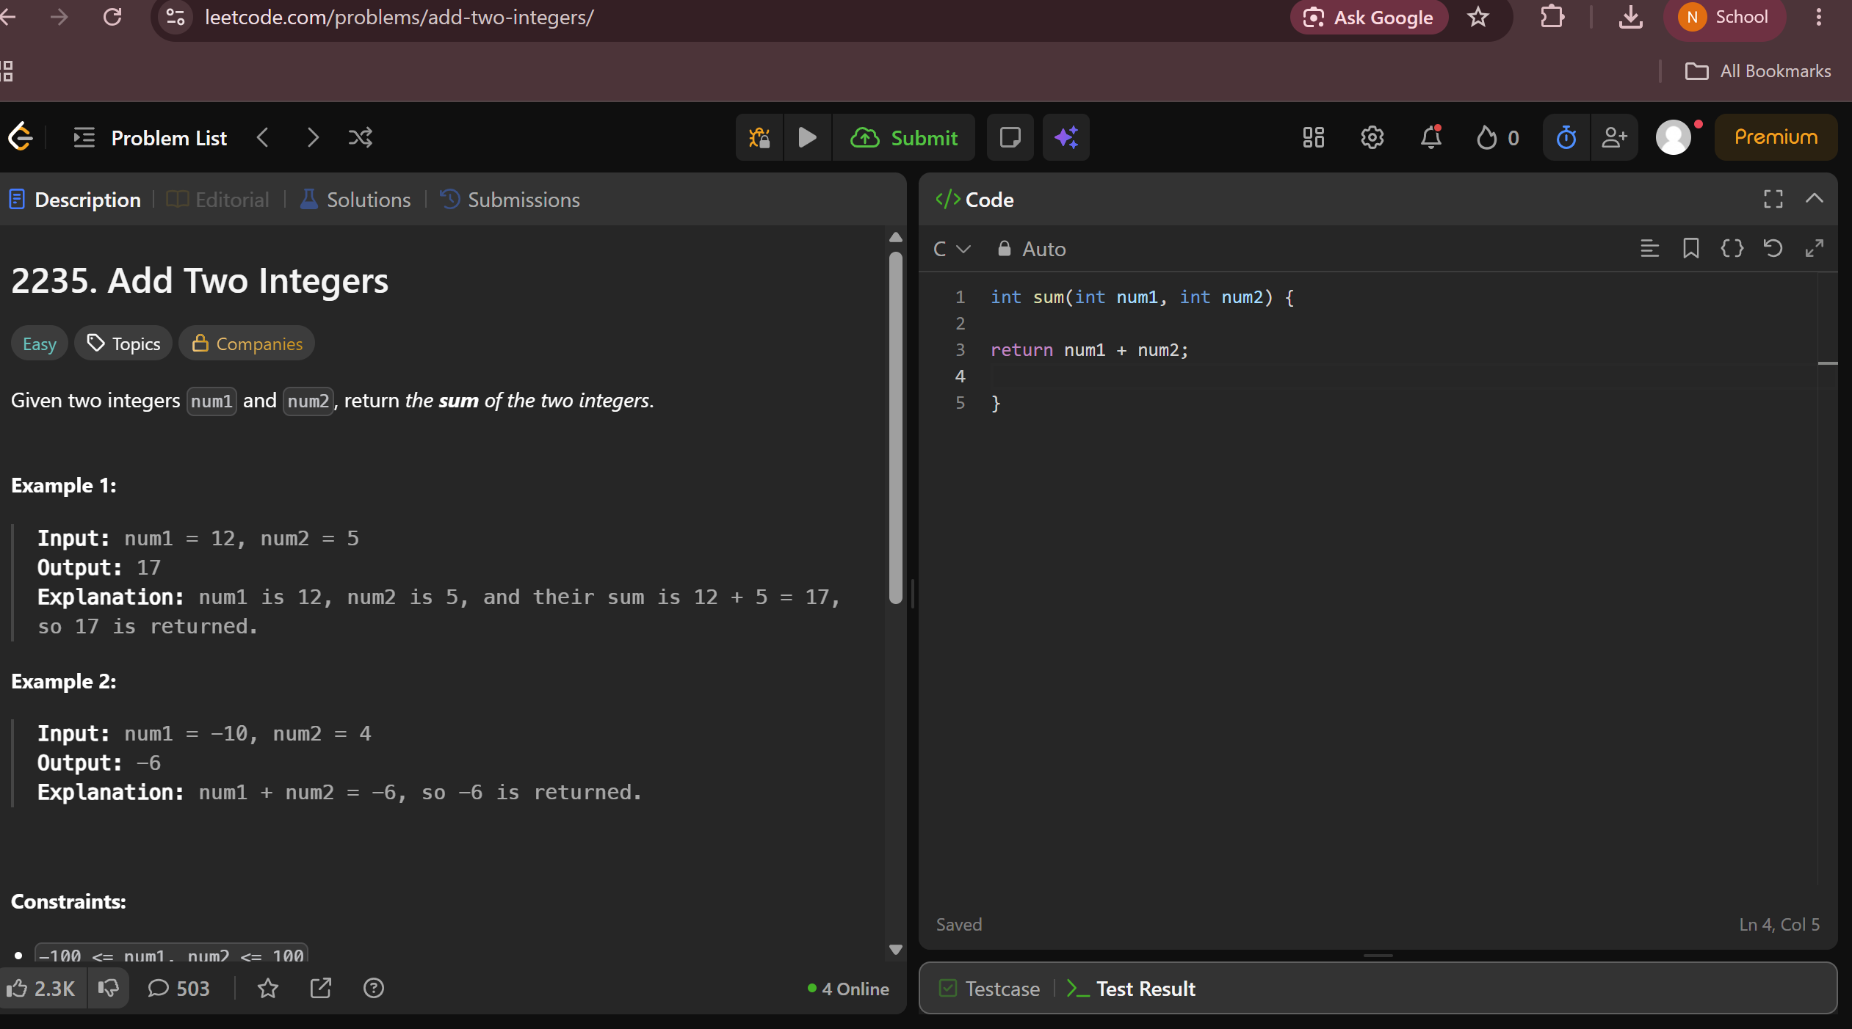
- https://leetcode.com/problems/calculate-delayed-arrival-time/description/

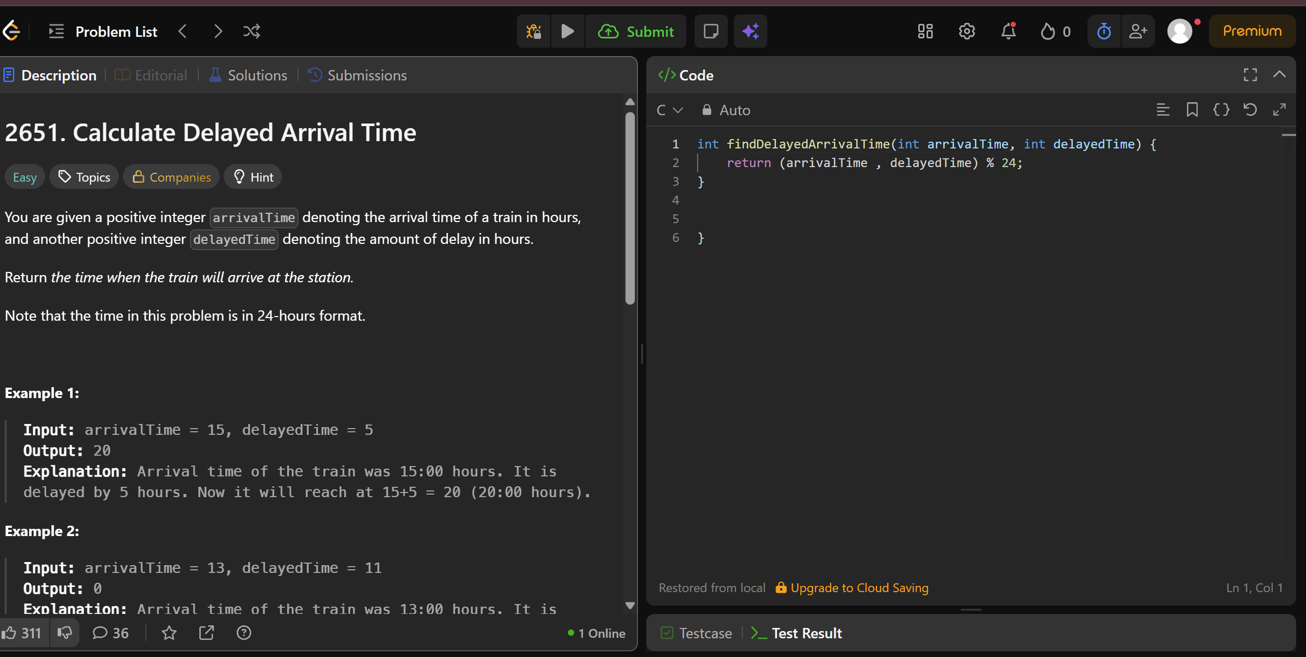
- https://leetcode.com/problems/total-distance-traveled/



